Full Stack Lab MST
Question 2:
Code:
<!DOCTYPE html>
<html>
<head>
<title>Promise Example</title>
</head>
<body>

<h2>Promise Demo (2 Seconds Delay)</h2>
<button onclick="fetchData()">Fetch Data</button>

<p id="output"></p>

<script>
function fetchData() {
let myPromise = new Promise(function(resolve, reject) {
setTimeout(function() {
resolve("Data fetched successfully");
}, 2000);
});
myPromise
.then(function(message) {
document.getElementById("output").innerText = message;
})
.catch(function(error) {
document.getElementById("output").innerText = error;
});
}
</script>

</body>
</html>
Output:
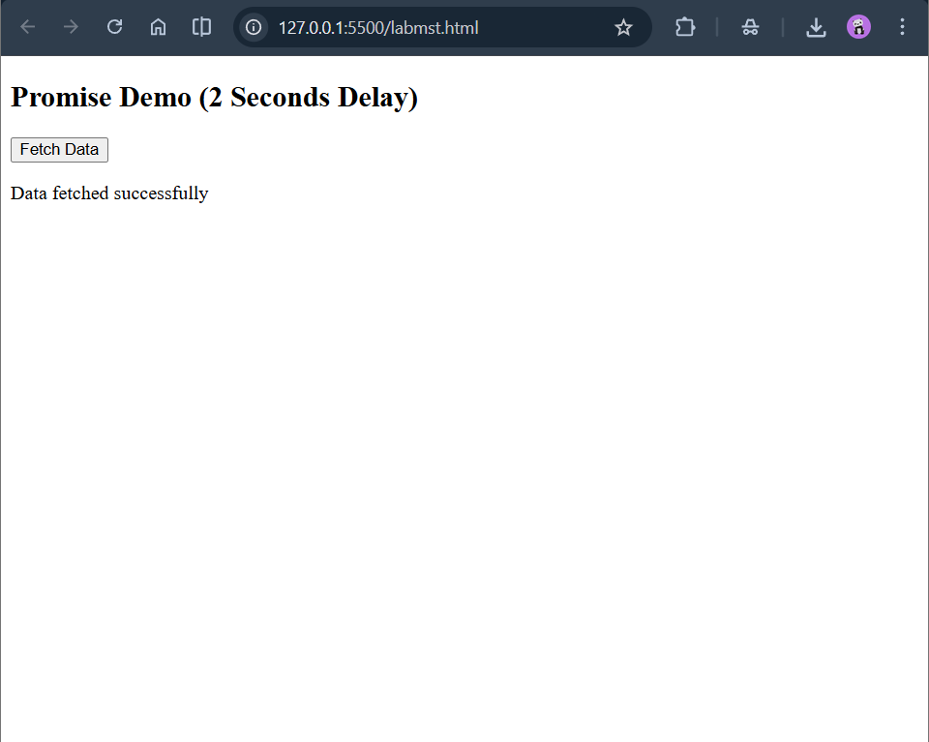

Question 4:
Code:
<!DOCTYPE html>
<html>
<head>
<title>List Add Remove</title>
</head>
<body>

<input type="text" id="itemInput" placeholder="Enter item">
<button onclick="addItem()">Add Item</button>
<button onclick="removeItem()">Remove Last Item</button>

<ul id="list"></ul>

<script>
function addItem() {
let input = document.getElementById("itemInput");
let li = document.createElement("li");
li.textContent = input.value;

document.getElementById("list").appendChild(li);
input.value = "";
}

function removeItem() {
let list = document.getElementById("list");
if (list.lastChild) {
list.removeChild(list.lastChild);
}
}
</script>

</body>
</html>

Output:
